.NET Solution Developer – Tyler Housand

1. What are IIS ‘Application Pools’ used for?

IIS Application Pools are used to create collections for applications. Using these collections, applications can be grouped together or isolated for configuring. For example, you can group applications together based on different versions of .NET framework or security levels. IIS Application Pools can also be used to ensure a disruption of service in one application pool does not affect services in other application pools.

1. What investigations could be undertaken to resolve a user seeing the following error page on the web application:

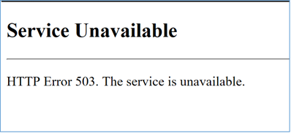

An HTTP error 503 is a server-side error that indicates the web server is not available to handle a request. Investigations that could be undertaken to resolve this issue would include checking if the server needs to be rebooted, checking if the server has enough resources to handle user traffic, checking that there are no errors in the code of the website on the server that would cause this, checking if the server is under maintenance, and checking if the server is under distributed denial-of-service attacks.

1. What colour is #666666 in CSS?

Gray40

1. What port is normally used for HTTPS/SSL traffic?

Port 443

1. What port is normally used for Microsoft SQL Server?

Port 1433

1. What are SOAPUI or POSTMAN applications normally used for?

SoapUI and Postman applications are normally used for testing web APIs.

1. Using C# code – write a method to take input integer, and turn these into words (make the range **from -9999 to 9999**) – so convert:

12 into the word “Twelve”, 45 into the words “Forty Five” and 634 in “Six Hundred and Thirty Four”, and -1987 as ‘Minus One Thousand, Nine Hundred and Eight Seven

1. Some screens have been installed to show media content at a customer site, with the following cabling:

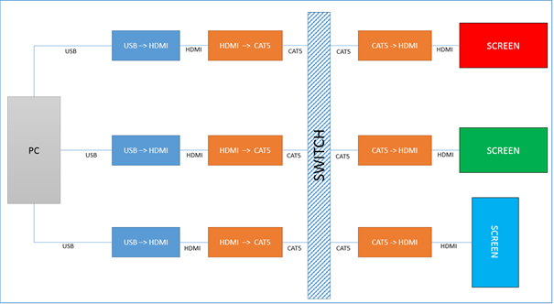

In summary – a PC showing media content is connected to 3 screens. The display is out via 3 USB to HDMI convertors - connected into HDMI-CAT5 transmitter/receivers connected over a network via a network switch. The screens are then connected to the CAT5->HDMI convertors, therefore receiving the media content.

You do not need to have knowledge of networking to answer this question.

These screens were installed last night and the engineers report said that the screens were working fine when they tested them before leaving. However, this morning on the first day of opening, the Customer Support Manager raises an urgent call that **all** the screens are ‘blank’.

* 1. Detail 2 or more possible causes for **all** screens being blank and manner in which the issue can be diagnosed?

Assuming that this is not a network issue and that both the PC and switch are successfully connected to the network, the first possible cause for all screens being blank would be that the PC itself is not working properly.

To address this issue, first I would check that the PC is on and connect it to a monitor directly. This testing would include using different cables and ports on the PC to check if anything works. If the monitor is blank after testing every port, it could be a driver issue. If checking the drivers doesn’t fix the issue, it could be a hardware issue and the ports in the computer themselves would need to be changed.

The second possible cause is the switch itself. Again, I would check that the switch is turned on and then begin checking if the physical ports on the switch are functioning. If testing the ports by connecting a monitor directly into each of the ports on the switch yields no results, the next step would be to check if the switch’s software is configured correctly and then try the ports again. If there are still no results, it potentially could be a hardware issue where the switch needs to be replaced.

If the PC and switch are confirmed to be functional, the next step would be to confirm that all of the cables involved are working properly.

* 1. How does this investigation change if only **one** screen is blank?

If only one screen is blank, it changes the investigation from focusing more on the switch and PC to focusing more on the blank screen itself. First, I would check that the screen is properly powered on and testing it if works when connecting it directly to another source. If the screen works with another source, the next step would be to test the cables that connect the screen to the switch to ensure they are functional. If the screen still does not work, it is potentially a hardware issue in the screen and it would need to be replaced.

1. Using the following database tables:

|  |  |  |
| --- | --- | --- |
| **Industry** | | |
| ID | Industry Name | Market Value |
| J | Consumer Electronics | 8 Billion |
| B | Mobile Telecoms | 2 Billion |

|  |  |  |  |
| --- | --- | --- | --- |
| **Salesperson** | | | |
| ID | Name | Age | Salary |
| 1 | Abe | 61 | 140000 |
| 2 | Bob | 34 | 44000 |
| 5 | Chris | 34 | 40000 |
| 7 | Dan | 41 | 52000 |
| 8 | Ken | 57 | 115000 |
| 11 | Joe | 38 | 38000 |

|  |  |  |  |
| --- | --- | --- | --- |
| **Customer** | | | |
| ID | Name | City | Industry Type |
| 4 | Samsonic | pleasant | J |
| 6 | Panasonic | oaktown | J |
| 7 | Samung | jackson | B |
| 9 | Orange | Jackson | B |

|  |  |  |  |  |
| --- | --- | --- | --- | --- |
| **Orders** | | | | |
| Number | order_date | cust_id | salesperson_id | Amount |
| 10 | 8/2/19 | 4 | 2 | 5400 |
| 20 | 30/1/19 | 4 | 8 | 18000 |
| 30 | 7/6/19 | 9 | 1 | 4600 |
| 40 | 1/7/19 | 7 | 2 | 24000 |
| 50 | 2/3/18 | 6 | 7 | 6000 |
| 60 | 3/2/19 | 6 | 7 | 7200 |
| 70 | 5/6/18 | 9 | 7 | 1500 |
| 80 | 5/5/19 | 7 | 2 | 3400 |
| 90 | 1/1/20 | 9 | 1 | 22000 |

1. Write SQL to show: The names of all salespeople that have an order with Samsonic.

SELECT DISTINCT salesperson.Name

FROM Salesperson salesperson INNER JOIN

Orders orders

ON orders.salesperson_id = salesperson.ID INNER JOIN

Customer customer

ON customer.ID = orders.cust_id

WHERE customer.ID = 4;

1. Write a single query that shows the number of sales, largest sale, and average sale per sales person, i.e.:

|  |  |  |  |
| --- | --- | --- | --- |
| **Salesperson** | **No_of_sales** | **Largest_sale** | **Average_sale** |
| Bob | 3 | 24000 | 10933.33 |

SELECT

salesperson.Name AS Salesperson,

COUNT(orders.salesperson_id) AS No_of_sales,

MAX(orders.Amount) AS Largest_sale,

AVG(orders.Amount) AS Average_sale

FROM Salesperson salesperson INNER JOIN

Orders orders

ON orders.salesperson_id = salesperson.ID

GROUP BY orders.salesperson_id;

1. A manager asks you to propose a report that shows ways in which salespeople could be ranked to their ‘value’. Propose **2 or more** ways how the ‘value’ of a sales person be evaluated.

The first new way that the salespeople could be ranked on their value would be to be to list the number of different customers that each salesperson has sold to. This could be added to the table above by adding this into the SELECT portion of the SQL command above:  
COUNT(orders.cust_id) AS No_of_different_customers

A second new way that the salespeople could be ranked on their value would be to compare the income they bring the company versus their salary. Assuming that the “Amount” column in the table above is a monetary amount, you could list the net income they bring by adding this to the SELECT portion of the SQL command above:  
SUM(orders.Amount) - salesperson.Salary AS Net_Company_Income

1. Please explain the differences between the following two SQL commands and any observations or issues or errors:
2. INSERT INTO Account VALUES

(1,'John','Adams','john@abc.com',123456,'12 Street', 'AB12 3DE', '01235 632563');

This command is used to insert a new row with a value for every column in the table. If a value is not present for every column, it will cause an error. If the values are not in the same order as the columns, it will also cause an error.

Without seeing the table itself, I cannot determine if this command would cause any errors.

1. INSERT INTO Account (ID,FirstName,LastName,Email,AccountNumber) VALUES (1,'John','Adams', 123456, john@abc.com);

This command is used insert a new row into the table with values only for the columns listed in the parentheses after Account. Any columns not listed will have a null value after the insert for this row. This could cause issues when running commands later that depend on the columns that now have null values in them.

One issue with this command is that the values are in the incorrect order. 123456 and john@abc.com should be switched to match the order of the columns in the parentheses. Another issue with this command is that the email, john@abc.com, needs to be in quotes. If the command is executed without the quotes, it will cause an error.

a)

Using the following publicly available example REST API: <https://jsonplaceholder.typicode.com/photos>

Write a simple Visual Studio MVC based web application to show a paged list of the items in the results.

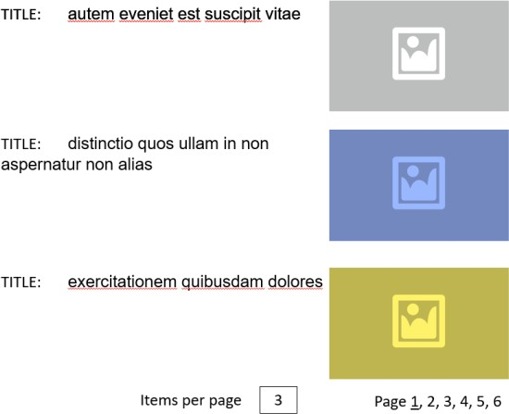

It should show the Title, the Thumbnail that is a link to the full image, a Textbox to define the number of items per page, and a selector for the page number.

1. Assuming we could alter any aspect of the site, or API, comment of some options for how to improve performance or efficiency of the MVC site, API or any other aspects.

One to improve the MVC site would be to have the paged list update without having to reload the page. This goes for changed pages and changed the number of items per page. However, without being more familiar with MVC, I’m not sure how this could be accomplished at the moment. Another improvement that could be made is that currently the albumId in the model is not being used for anything. This could be removed or instead used for some sort of sorting.

1. Considering that the API **is** a third party API that we **cannot** alter, propose a solution on how we could allow a web-user to mark a photo as ‘favourite, and to be able to come back at a later point and see a list of their ‘favourite’ photos. Provide as much detail for the solution as you feel is necessary.

If the API is a third party API that cannot be altered, a solution to allow web-users to mark photos as ‘favorite’ and be able to come back to them at a later point would first involve a user registration system. With user accounds, the IDs of photos could be stored to their accounts. There, the IDs stored could be used to sort through the results and only show the favorited ones.